

CSE302: Database Systems (Section No. 10)
[Fall 2025]

Project Report

Student Management System of EWU

Project URL/Link:
https://github.com/SHOJIB-80/STUDENT-MANAGEMENT-SYSTEM-DATABASE-

Submitted by:

Student ID | Student Name | Contribution Percentage
2023-3-60-553 | Md Sabir Islam Rafy | 33.33%
2024-1-60-291 | MD Sirajul Islam | 33.33%
2024-1-60-264 | Shahriar Islam Nafis | 33.33%

PROJECT DESCRIPTION

EWU Student Management System is a web-based application designed to automate and manage academic and administrative activities of East West University. The system provides a centralized platform for managing student information, course registration, enrollment, academic records, and administrative control.
The main goal of the system is to reduce manual paperwork, improve data accuracy, and provide fast access to student-related information for students, faculty members, and administrators. By integrating a structured database with role-based access control, the system ensures secure and efficient management of university operations.
This project simulates a real-world university management environment and demonstrates the practical use of database systems, backend logic, and user authentication mechanisms.

KEY FEATURES

- User Authentication and Role Management
The system provides secure login for users with different roles such as Admin, Student, and Faculty. Each role has controlled access to system functionalities.
- Student Information Management
The system stores and manages student details including student ID, name, email, phone number, and enrollment date.
- Course Management
Admin can add, update, and manage course information such as course code, course name, credits, enrollment capacity, and registration period.
- Faculty Management
Faculty members are assigned to courses, and their basic information is maintained in the system.
- Online Course Enrollment
Students can enroll in available courses within the defined enrollment period. Enrollment status is maintained for each course.
- Enrollment Tracking and Status Control
The system tracks enrollment status (enrolled or dropped) and maintains enrollment history for each student.
- Grade Management
Grades are stored for each student’s enrolled course and can be updated by authorized users.
- Centralized Database System
All academic and user data are stored in a structured relational database ensuring data consistency and integrity.

SYSTEM DESIGN

1. System Architecture
The EWU Student Management System follows a three-tier architecture:
- Presentation Layer: User interface for students and admin.
- Application Layer: Handles business logic such as enrollment validation and role-based access.
- Database Layer: Stores all system data in a MySQL relational database.

2. Database Design
The database consists of the following main entities:
- Users: Stores login credentials and user roles.
- Students: Contains student profile information.
- Faculties: Stores faculty details.
- Courses: Holds course-related information.
- Enrollments: Manages student-course relationships and grades.
Primary keys and foreign keys are used to maintain relationships and ensure data integrity.

3. ER Diagram Design
The ER diagram represents the relationships among Students, Courses, Faculties, Users, and Enrollments.
- Students and Courses have a many-to-many relationship resolved through the Enrollment entity.
- Each Course is associated with one Faculty.
- Each User account may reference one Student record.

4. Data Flow
- Admin creates courses
- Students register and enroll in courses.
- Enrollment records store course status and grades.
- Users retrieve data based on assigned roles.

 
 
 
 

TOOLS AND LANGUAGES

1. Database

MySQL → Used to store and manage data such as users, menu items, orders, and order details

2. Backend Language

➢ PHP → Used for server-side scripting to connect the database with the web pages and handle user requests. 
 
 

3. Frontend Languages

- HTML → For creating the structure of the web pages. 
- CSS → For designing and styling the web pages to look user-friendly. 
- PHP→ PHP connects frontend pages with MySQL database. 
 
 

4. Development Tools

- XAMPP → Provides Apache server and MySQL database in one package to  run the project locally. 
- phpMyAdmin → Used to manage the MySQL database easily. 
- Code Editor (like VS Code, Sublime Text). 
 

5. Diagram Tools

➢ Draw.io → Used for creating ER diagrams and workflow diagrams. 
 
- Admin:

Full access to the system.
Can manage students: add, edit, delete, and view user accounts.
Can manage the courses: add courses
Can manage enrollments: view all enrollments

- Student

Can register and log in.
Can enroll/drop available courses
Can view enrollments.

E-R DIAGRAM

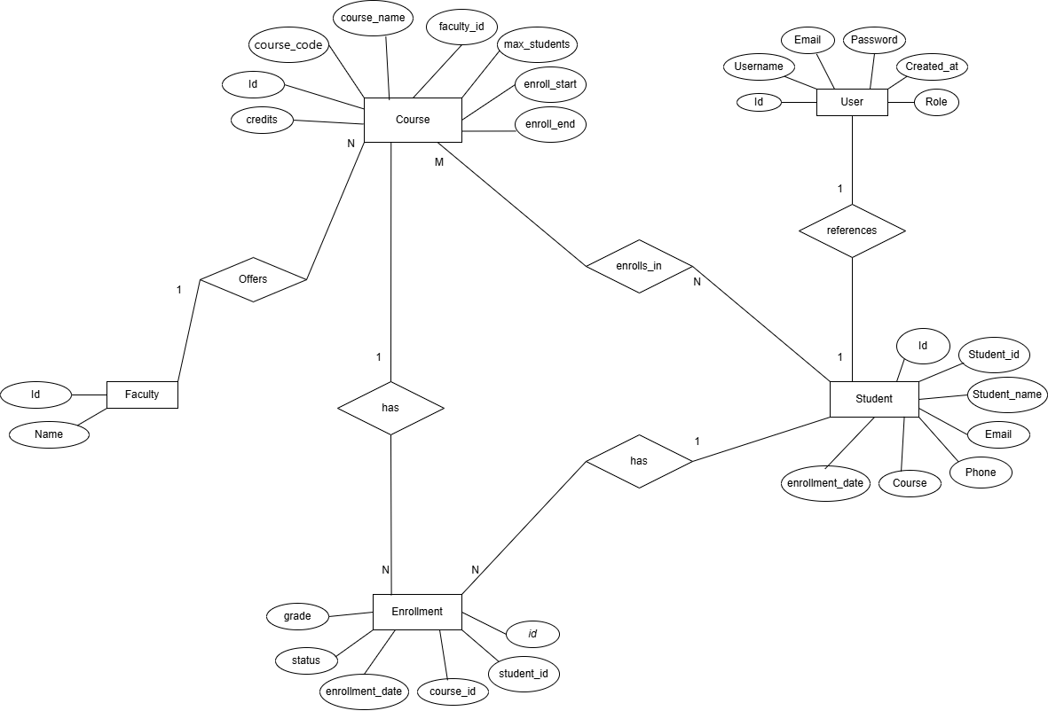

RELATIONAL MODEL

➢ One User can manage many Students (Admin).
➢ One User can manage many Courses (Admin).
➢ One Student can enroll in many Courses.
➢ One Course can have many Enrollments.
➢ One Enrollment belongs to one Student.
➢ One Enrollment belongs to one Course.
➢ One Course can appear in many Enrollments.
➢ One Student can have many Enrollments. 
 
 
 
 
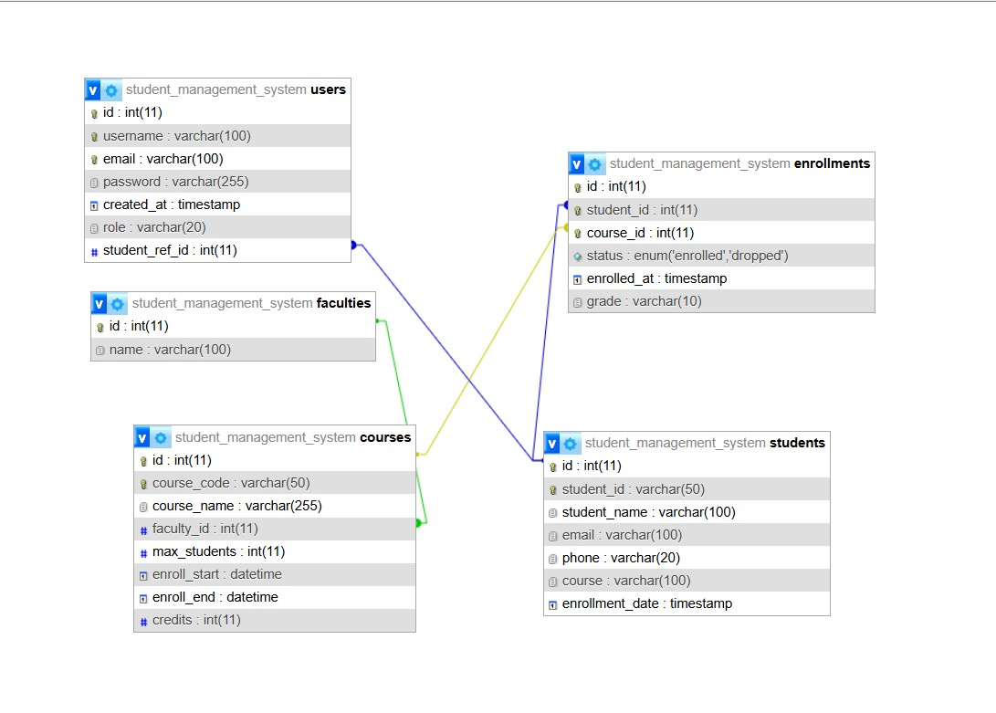 

- GUI SCREESHOT 

Register interfase:

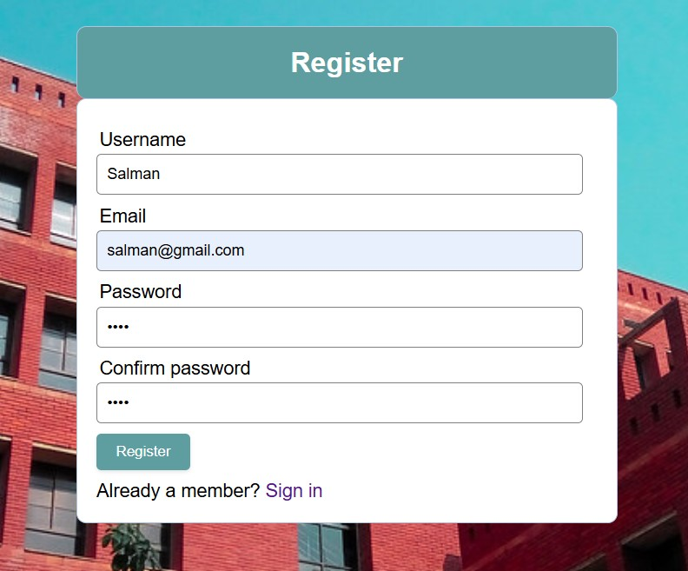

Login interfase:

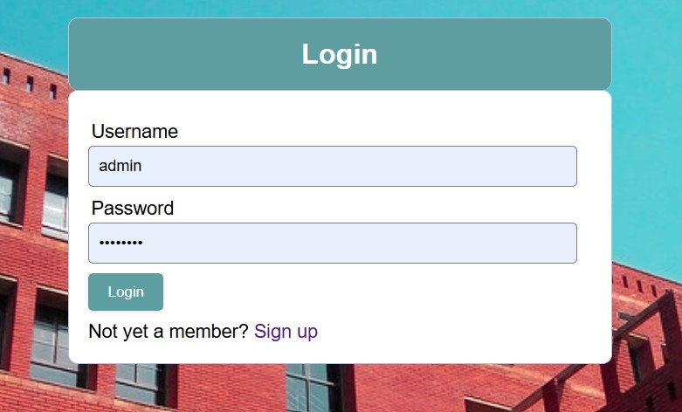

Login as student:

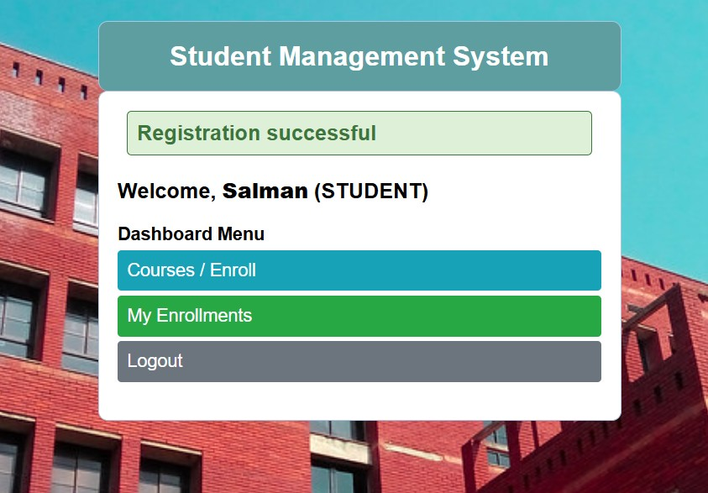

Login as admin:

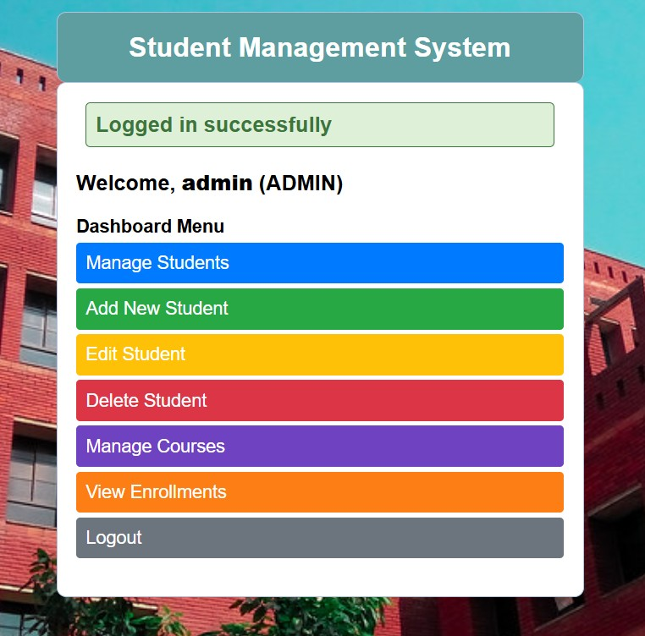

Manage students & Search Stutent:
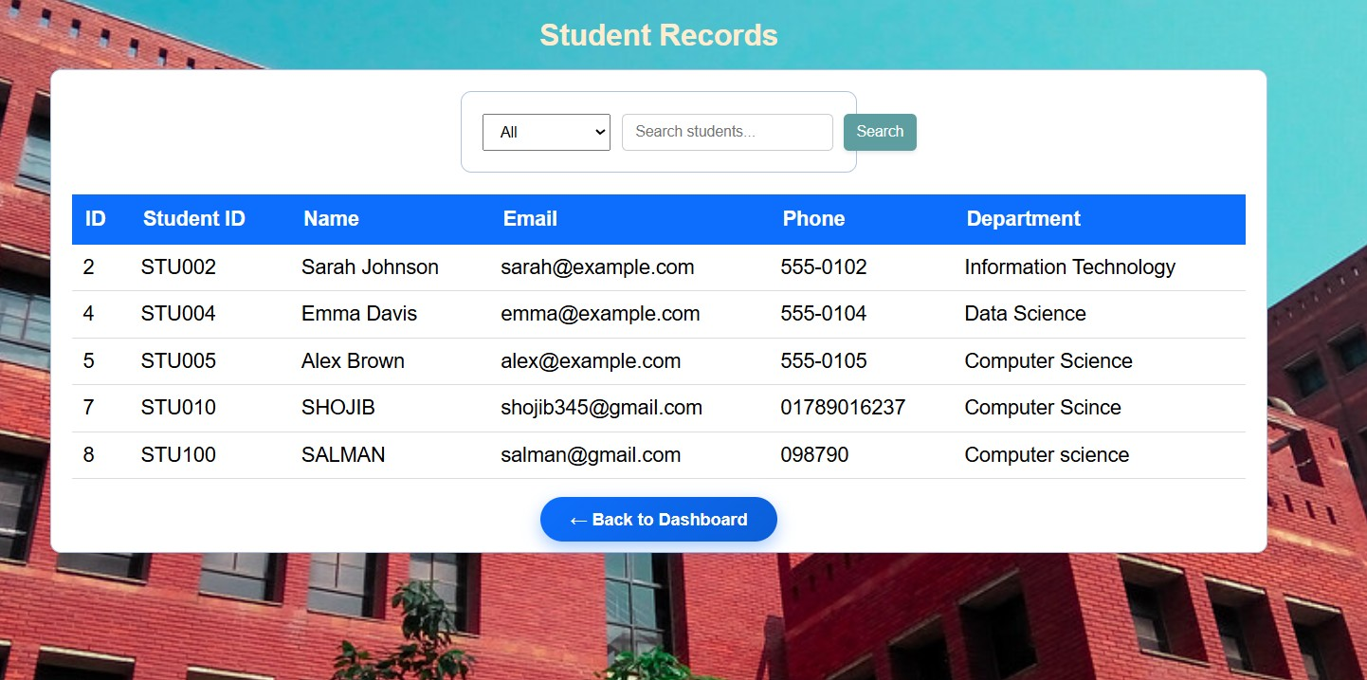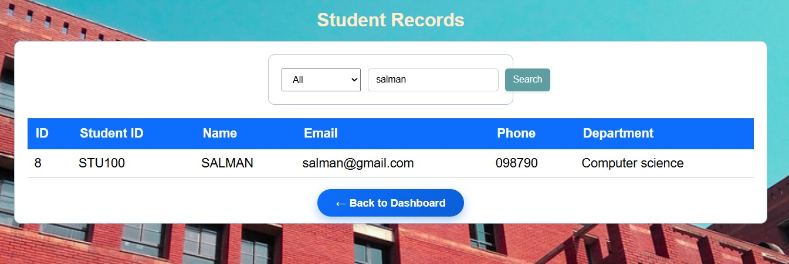

Delete Student:
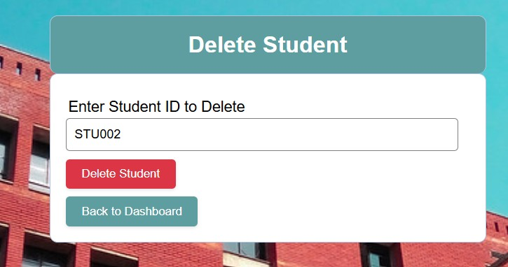

ADD Student:

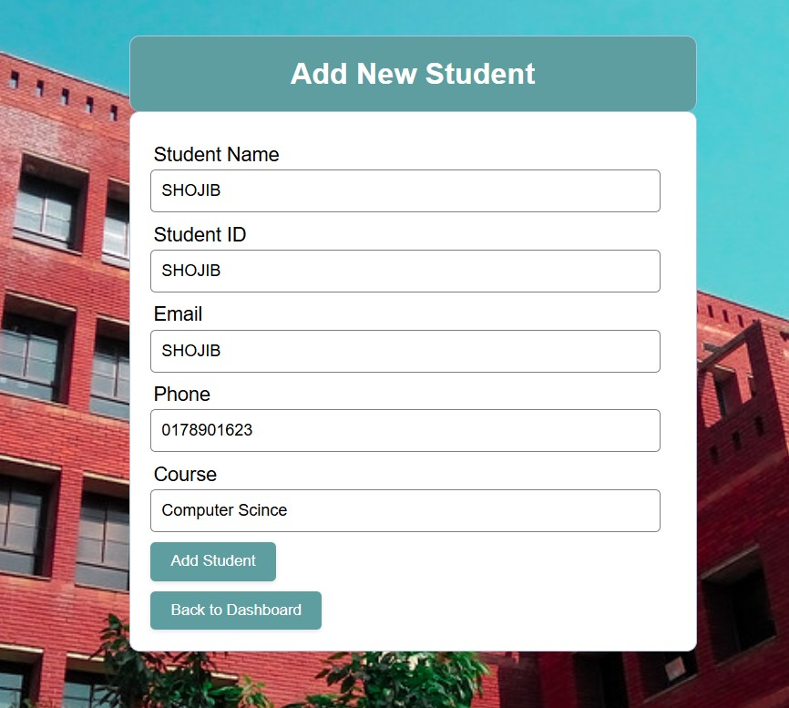

Edit Student:

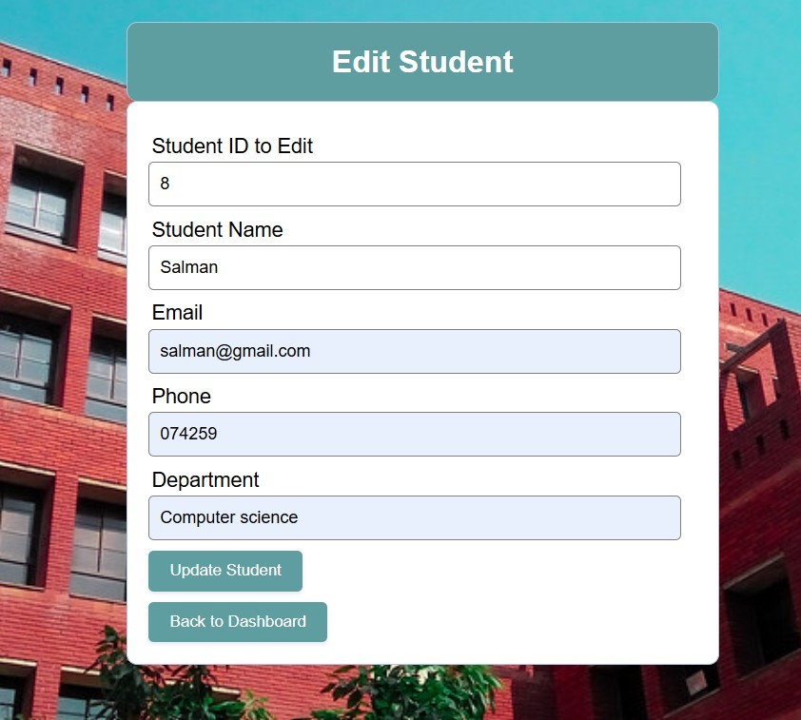

Manage Courses:
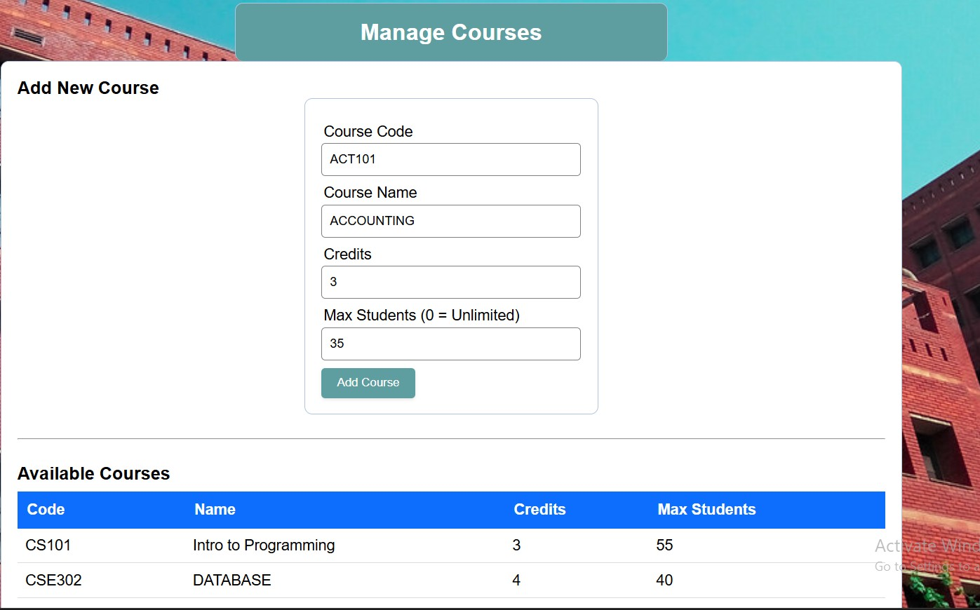

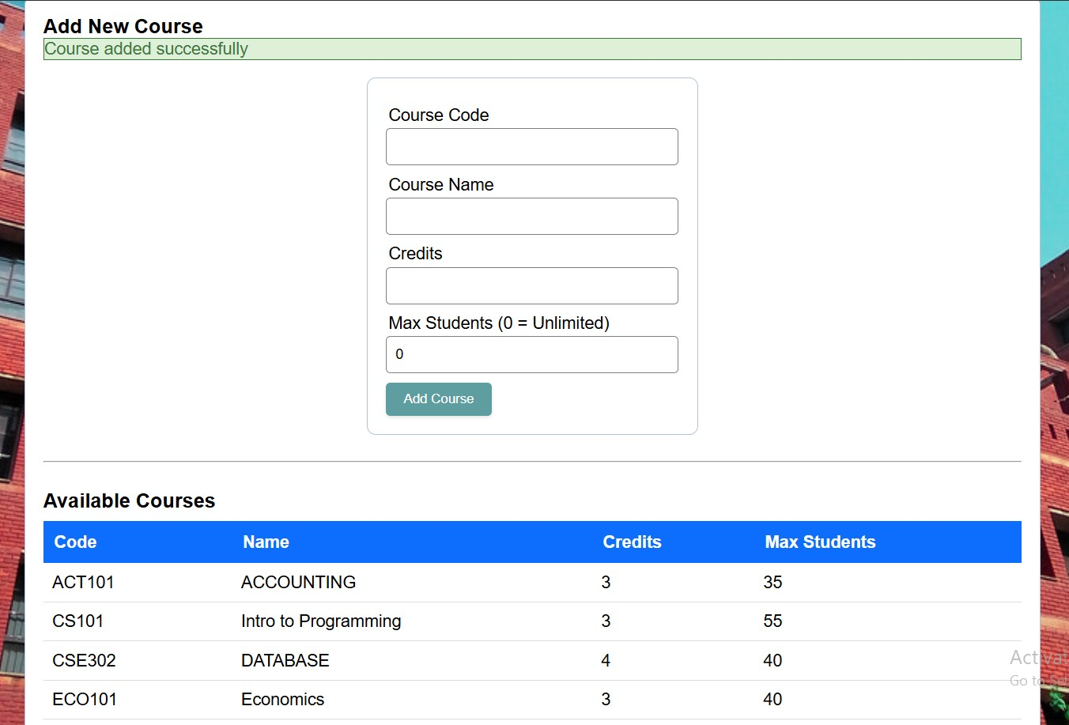

View Enrollments:
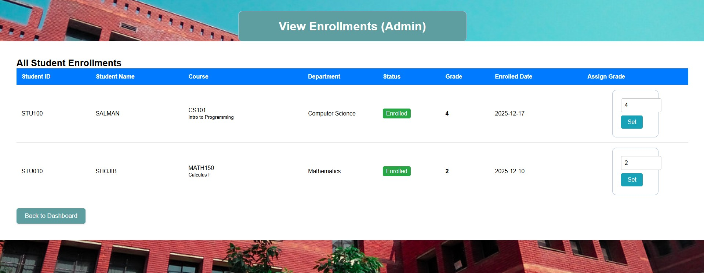

LIMITATIONS
• Limited Role Functionality
The system supports basic roles (Admin, Student ) but advanced role-based permissions (such as advisor, department head, or registrar) are not implemented.
• No Automated CGPA Calculation
Although grades are stored in the enrollment table, the system does not automatically calculate semester-wise GPA or cumulative CGPA.
• Basic Course Registration Rules
Advanced constraints such as prerequisite checking, course retake rules, and waitlisting are not supported.
• Scalability Constraints
The system is designed for academic demonstration purposes and may face performance issues with a very large number of students or concurrent users.
• Limited Security Features
While password authentication exists, advanced security mechanisms such as two-factor authentication, activity logging, and encryption are not included.
• No Notification System
The system does not provide email or SMS notifications for enrollment confirmation, deadlines, or grade publication.
• Static Semester Handling
Semester and academic calendar management is static and requires manual updates by the administrator.

CONCLUSION

The EWU Student Management System successfully demonstrates an effective approach to managing student information, course offerings, faculty assignments, and enrollment processes using a relational database system. By integrating entities such as Students, Courses, Faculties, Users, and Enrollments, the system ensures data consistency and structured academic record management.
This project highlights the practical implementation of database concepts such as primary keys, foreign keys, relationships, and normalization. Although the system has certain limitations, it serves as a strong foundational model for a real-world university management system. With further enhancements such as advanced security, GPA calculation, and notification features, the system can be expanded into a fully functional enterprise-level academic management solution.

REFERENCES

- Silberschatz, A., Korth, H. F., & Sudarshan, S. (2019). Database System Concepts (7th Edition). McGraw-Hill Education.
- W3Schools – https://www.w3schools.com (for learning HTML, CSS, PHP, and MySQL basics).
- East West University. (n.d.). Academic System Overview.
https://www.ewubd.edu
- GeeksforGeeks – https://www.geeksforgeeks.org (for database and PHP programming concepts).
- TutorialsPoint – https://www.tutorialspoint.com (for SQL queries and PHP examples).
- XAMPP Documentation – https://www.apachefriends.org (for installation and server setup).
- Draw.io – https://app.diagrams.net (for drawing ER diagrams and workflow diagrams).

